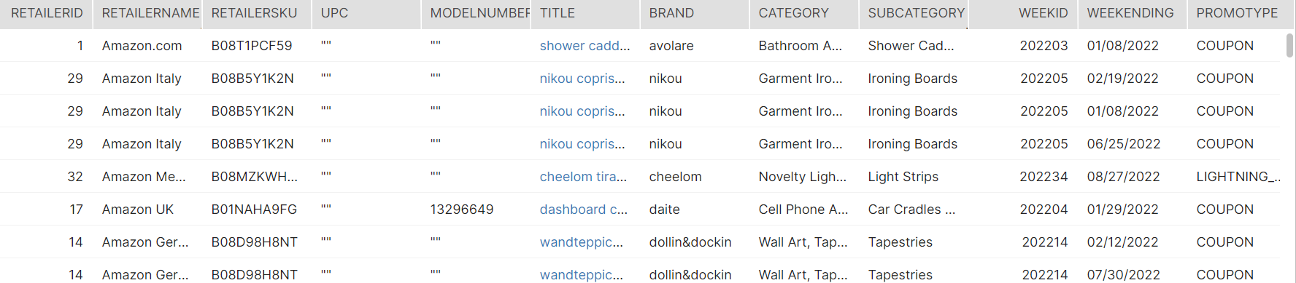

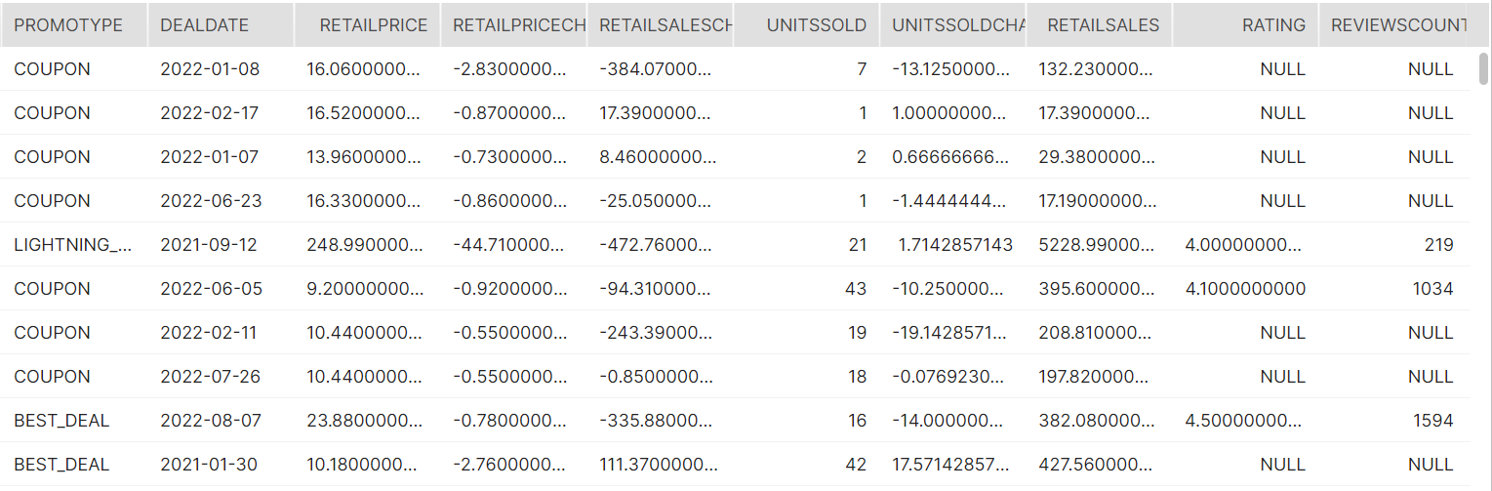

SELECT R.RETAILERID,

COALESCE(S.RETAILERNAME, RV.RETAILERNAME, CS.RETAILERNAME, P.RETAILERNAME) AS RETAILERNAME,

R.RETAILERSKU,

COALESCE(S.UPC, RV.UPC, CS.UPC, P.UPC) AS UPC,

COALESCE(S.MODELNUMBER, RV.MODELNUMBER, CS.MODELNUMBER, P.MODELNUMBER) AS MODELNUMBER,

COALESCE(S.TITLE, RV.TITLE, CS.TITLE, P.TITLE) AS TITLE,

COALESCE(S.BRAND, RV.BRAND, CS.BRAND, P.BRAND) AS BRAND,

COALESCE(S.CATEGORY, RV.CATEGORY, CS.CATEGORY, P.CATEGORY) AS CATEGORY,

COALESCE(S.SUBCATEGORY, RV.SUBCATEGORY, CS.SUBCATEGORY, P.SUBCATEGORY) AS SUBCATEGORY,

R.WEEKID,

COALESCE(S.WEEKENDING, RV.WEEKENDING, CS.WEEKENDING, P.WEEKENDING) AS WEEKENDING,

P.PROMOTYPE AS PROMOTYPE,

P.DEALDATE AS DEALDATE,

COALESCE(S.RETAILPRICE, P.RETAILPRICE) AS RETAILPRICE,

P.RETAILPRICECHANGE AS RETAILPRICECHANGE,

P.RETAILSALESCHANGE AS RETAILSALESCHANGE,

COALESCE(S.UNITSSOLD, P.UNITSSOLD) AS UNITSSOLD,

P.UNITSSOLDCHANGE AS UNITSSOLDCHANGE,

COALESCE(S.RETAILSALES, RV.RETAILSALES, CS.RETAILSALES, P.RETAILSALES) AS RETAILSALES,

RV.RATING AS RATING,

RV.REVIEWSCOUNT AS REVIEWSCOUNT

FROM DEV_EDW.PUBLIC.STACKLINE_RETAILERS R

LEFT OUTER JOIN "PROD_RAW"."STACKLINE".SALES S

ON R.RETAILERID = S.RETAILERID

AND R.RETAILERSKU = S.RETAILERSKU

AND R.WEEKID = S.WEEKID

LEFT OUTER JOIN "PROD_RAW"."STACKLINE".RATINGSREVIEWS RV

ON R.RETAILERID = RV.RETAILERID

AND R.RETAILERSKU = RV.RETAILERSKU

AND R.WEEKID = RV.WEEKID

LEFT OUTER JOIN "PROD_RAW"."STACKLINE".CONTENTSCORE CS

ON R.RETAILERID = CS.RETAILERID

AND R.RETAILERSKU = CS.RETAILERSKU

AND R.WEEKID = CS.WEEKID

LEFT OUTER JOIN "PROD_RAW"."STACKLINE".PROMOTIONS P

ON R.RETAILERID = P.RETAILERID

AND R.RETAILERSKU = P.RETAILERSKU

WHERE R.WEEKID LIKE '2022%'

